***MEDIA ALERT***

Shinola and Sasha Bruce Youthwork to host job skills panel discussion for D.C. homeless youth
Detroit-based design brand partners with youth and community nonprofit for special event on June 27
Washington, D.C. (June 22, 2016) — On Monday, June 27, Detroit-based design brand, watchmaker and leather goods manufacturer Shinola will join charity partner Sasha Bruce Youthwork (SBY), a 41-year-old service organization dedicated to improving the lives of youth and families in D.C., to host a special job skills panel discussion at the Shinola D.C. flagship store (1631 14th Street NW).

D.C. Deputy Mayor Brian T. Kenner will moderate the panel for an audience of more than 20 SBY youths, leading a discussion focused on job skills, leadership and preparing for success. The event will include a diverse panel of experts and notables:
- Jacques Panis, Shinola president
- Justin Anderson, Dallas Mavericks NBA player and Montrose Christian School graduate
- Vildana “Sunni” Puric, WPGC 95.5FM radio personality and Detroit native
- Charmia Carolina, Sasha Bruce Youthwork alumnus

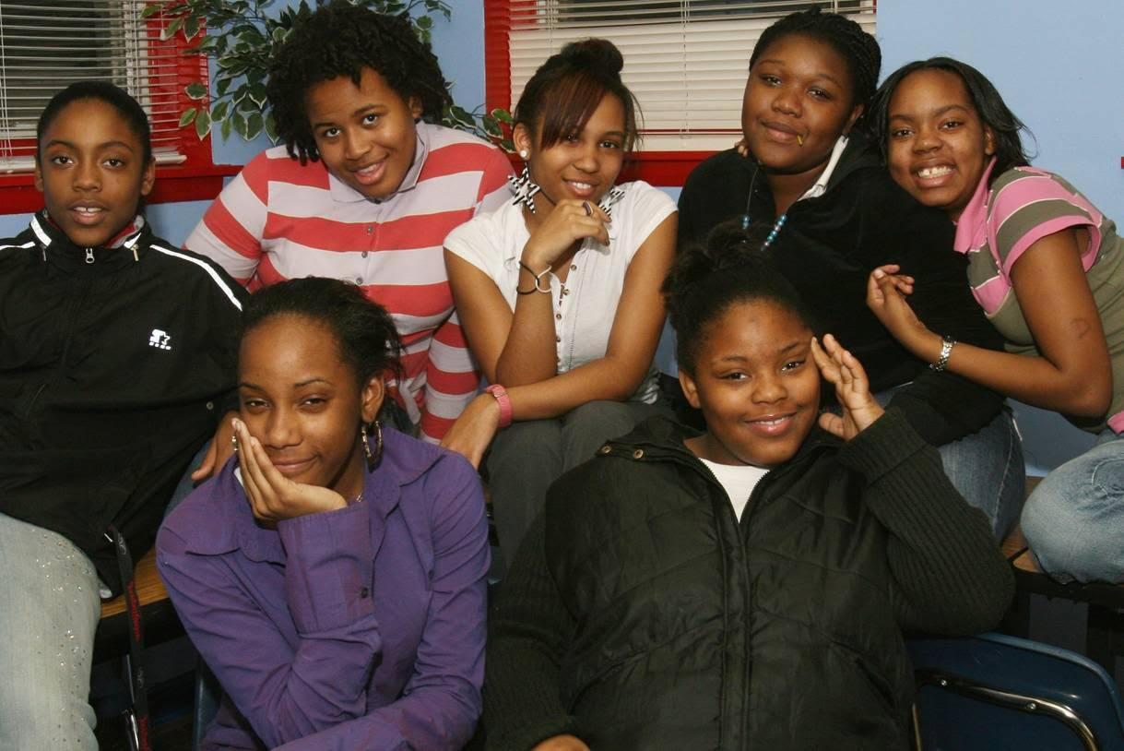

Washington, D.C.-area youth from Sasha Bruce Youthwork. (Photo courtesy of SBY)
The panelists will cover a range of topics and offer insight into their lives and careers, imparting wisdom and knowledge about the importance of education, handling success under pressure, overcoming adversity, sharpening job skills and much more.

“Job creation is at the heart of everything we do at Shinola,” says Panis. “I’m thrilled to have the opportunity to speak directly to a community of young people searching for both jobs and security. This panel discussion is the perfect platform to help educate D.C. youth about what Shinola looks for when we’re hiring everyone from factory workers to executives."
“The ongoing recession has hit poor families particularly hard, and in light of shrinking government support for workforce training for disconnected youth, this opportunity to offer professional development advice from business and entertainment leaders couldn’t have come at a better time,” adds Sasha Bruce Youthwork founder and executive director Deborah Shore. “Our panel discussion with Shinola is a model for for-profit and non-profit partnerships.”
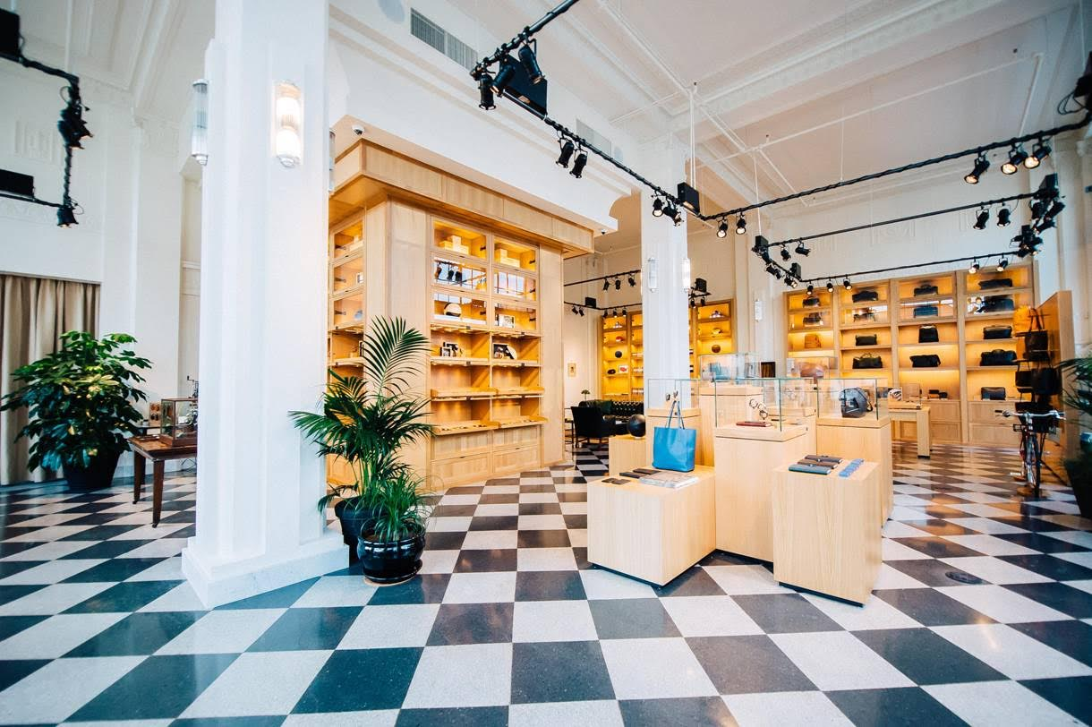
Interior of the Shinola D.C. flagship store on 14th Street. (Photo by Joy Asico)
About Shinola
Founded in 2011, Shinola was conceived with the belief that products should be well made and built to last. As makers of modern watches, bicycles, journals and leather goods, Shinola stands for skill at scale, the preservation of craft and the beauty of industry.
About Sasha Bruce Youthwork
Sasha Bruce Youthwork (SBY) is a multi-service nonprofit agency dedicated to offering safe homes, life skills, and workforce and educational opportunities for DC area youth. Founded 41 years ago by its Executive Director, Deborah Shore, SBY has developed its unique approach, which combines proven youth development practices with pioneering family strengthening strategies called Competency Based youth work. SBY provides a continuum of services that strengthen families, help youth develop life skills, and discover pathways to becoming self-sufficient and contributing members of our city and world. The Sasha Bruce House, located on Capitol Hill, is the District of Columbia’s only open-access, youth-specific emergency shelter.
Press Contact
Arienne Thompson of MoKi Media: arienne.thompson@mokimedia.com or 901.283.6360

